Illustrations of Energy and Energy Transformations

Using the picture, find as many forms of energy as you can. Following the chart below, color the parts of the illustration where you might find each of the four forms of energy. You may find more than one example of each – stop at 3 of each.
Form of energy | Color
Electrical energy | yellow
Thermal (heat) energy | red
Chemical energy | blue
Mechanical energy | green
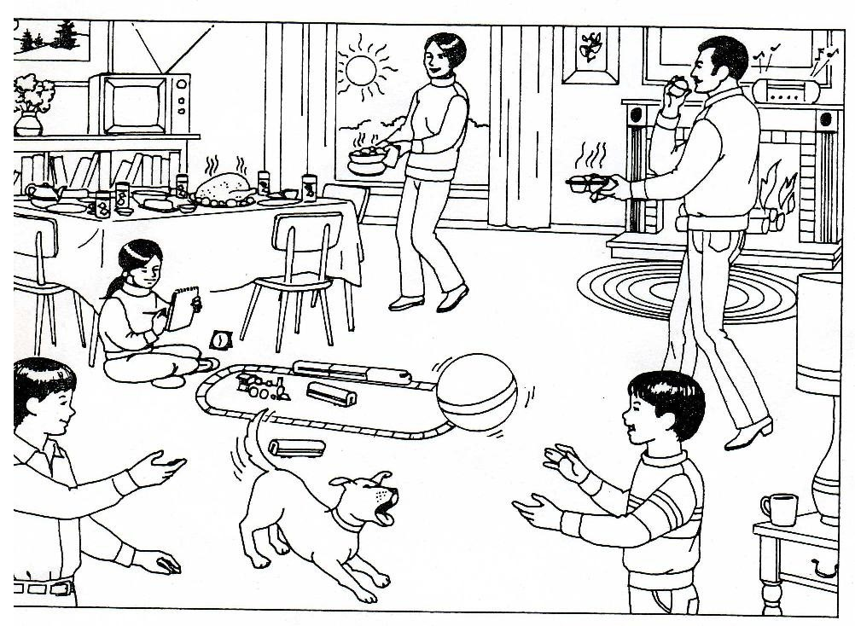

BONUS CHALLENGE: On the diagram write in a number beside any energy transformations you can identify. Record the type of transformation and the steps in the table at the bottom of the page. You may use the back of this sheet if you need more room.
Number on Diagram | Type of Transformation | Steps (Types of Energy) ex. chemical —> mechanical

